*B.Tech. 3rd Semester Assignment*

**DATA STRUCTURES**

**1.1** Create an attendance file ”attendance.txt” that contains roll numbers, names and attendances of all students on different dates. Given your attendance file, store the information of the student in appropriate structure to compute the following: (Write a menu driven program.)

* print % of attendance of each student till a particular date and store the results in a file.
* print the details of the student who has the highest percentage of attendance till a particular date.
* print the total number of classes taken by the teacher
* print the details of the student who has the lowest percentage of attendance till a particular date.
* print the mean percentage of attendance till a particular date.
* ..... (if you can extract any other information from attendance)

**# Algorithm to Generate Random Numbers, Perform Bubble Sort, and Calculate Swaps:**

Start

Include the necessary header files.

Declare the functions used in program.

Initialize variables and data structures.

**Step-1:**

**Step-2:**

**Step-3:**

**Step-4:**

**Step-5:**

**Step-6:**

**Step-7:**

**Step-8:**

Create helper functions for extracting integers from strings, loading attendance data from a file, calculating attendance percentages, and printing attendance data.

Seeding the random number generator with the current time.

User input for the number 'n' (the size of the set).

Check if files with the same set size and run number already exist in the folder and if found, delete the existing files for the each of the 10 runs.

Load attendance data and Read student information and attendance data from a CSV file into an array of Student structures.

* Calculating attendance percentages.
* Finding the student with the highest and lowest attendance.
* Calculating the mean attendance percentage.
* Printing the total number of students & classes taken.
* Printing a sorted list of students.
* Searching for a student by name or roll number.

Create a menu-driven function for user interactions and include options:

Calculate the attendance percentage for each student until a specified date and allocate memory for an array of structures to store this information.

**Step-9:**

**Step-10:**

**Note:**

Main program offers options to the user:

* Manually enter the filename or use a default filename ("attendance.txt").
* Load attendance data, display the menu, and allow user interactions.
* Perform operations based on user's selections.

End

The user should input a valid CSV file with the specified format (roll number, name, and attendance data) for the program to work correctly.

**#Output:**

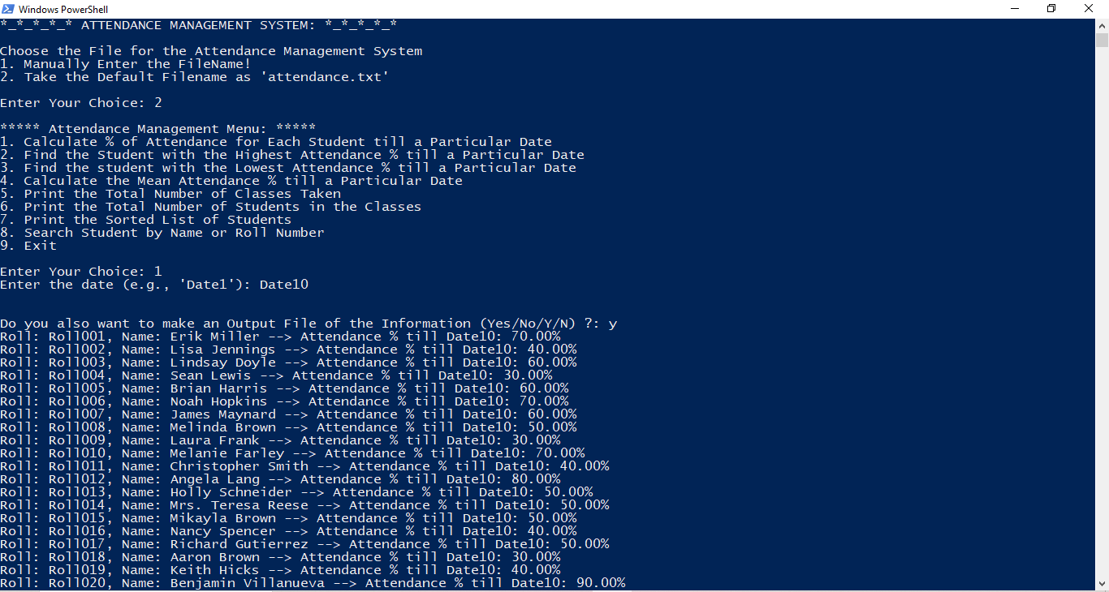

**Start**

**# Flow-Chart:**

**Prompt the user and read the input file. Manually enter the filename or use a default filename ("attendance.txt").**

**Load attendance data and Read student information and attendance data from a CSV file into an array of Student structures.**

**Calculate the attendance percentage for each student until a specified date and allocate memory for an array of structures to store this information.**

**Display the attendance data according to the operations selected by user.**

**Calculating attendance percentages.**

**Finding the student with the highest and lowest attendance.**

**Calculating the mean attendance percentage.**

**Printing the total number of students & classes taken.**

**Printing a sorted list of students.**

**Searching for a student by name or roll number.**

**Create a menu-driven function for user and load attendance data, display the menu, and allow user interactions.** **perform operations based on user's selections.**

**End**